EPQ REFLECTIVE JOURNAL

Why we do it and what it should contain

From page 4 “ you gain marks for organisation and reflection” top band mark scheme says “The learner shows a high level of organisational ability and time management skills when managing the project. The learner maintains clear and detailed records of activities undertaken during the project, including problems encountered and steps taken to overcome them. Progress is monitored vs the original plan and adjustments made to it were necessary”

Example:

Avoid mere description, but provide reflections that show thinking:

“ I went to the library and got some books..”

“ I attempted to find some books from the college library but was unable to find anything until I asked for help. She showed me how… and so then I did this… and after I will do this…

31/03/2025:

I began working on ideas for my epq, during the

Brainstorming leading up to and during my first lesson I

Concluded that I would like my epq to be linked to economics

As Its my favoured subject and a possible employment route

In future so skilling up and learning about a specific could help

My learn more about the industry.

09/04/2025:

With the range on what my epq could be around being vast I

needed to narrow down my options, I created a few possibilities

based from conversations with my boss (an accountant) who

suggested looking into the housing vs rental market, videos

on youtube (Garys economics) discussing inequality of assets

as well as books such as “the secret life of marc rich” where I

could deep dive Into a specific, market (e.g. oil)

other possibilities included conversations around AI in labor

markets and crypto currency.

11/04/25:

With some possibilities in hand I asked Microsoft’s copilot to give each possible topic a score /100 based on Available Knowledge, Subject Niche, Depth & Debate, Conclusion Availability, Specificity & Manageability and Presentation & Organization.

While this did point out some of the options strongest points the AI wasn’t able to give accurate scoring, as basically all subjects were in the 80-90 range.

In the end I ruled out crypto currency’s ( specifically a question on if they can rule out physical currency’s ) as it is highly speculative and so hard to write about in depth. It was the same with AI. This left specific markets, inequality and housing.

In the end, i went online and tried to find some examples to see which I could best see myself doing, I used [The Student Room](https://www.thestudentroom.co.uk/) as ita a great way to see posts and replies from students in similar positions. For example I found this thread:

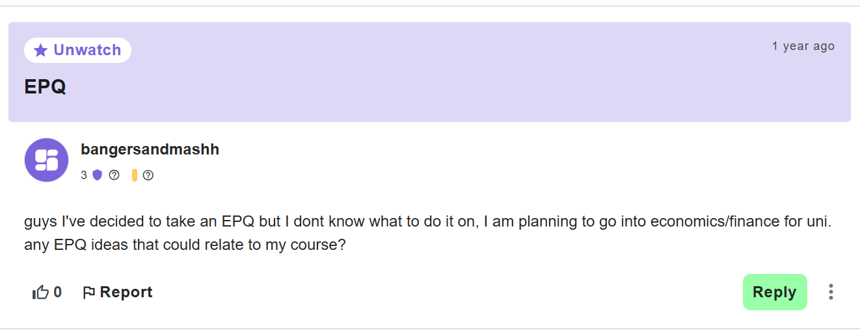

Which had someone in an extremely similar position his replies gave him some examples, including someone recommending the increase of wealth inequality in the UK, as this is something I have already looked at. Unfortunately I didn’t find any specific epqs based on a similar topic, so I went back to copilot and and asked for possible upsides and downsides of a epq on wealth inequality in the uk, specifically how economic growth can impact. (this was something that garys economics looked at) Aswell as a example essay plan.

This was much more effective than asking for a score /100 and provided me with many pros and cons. Including that it doesn’t have massive debate potential, or to come to a conclusion so I reworded the title so that it can be “attacked more from either side” aswell as being able to come up with a conclusion. I ended on **“To what extent does the UK’s economic growth fuel rising wealth inequality, and is this trend ultimately a burden on the country’s long-term socio-economic development?”**

20/04/25:

After taking a break from thinking about epq, I talked with a friend who has just submitted his epq ( ai on investment banking) and he said that my title is way to long, which was annoying, but I saw his point on it being “Punchy” and so I shorted it to “**To what extent does the UK’s economic growth fuel rising wealth inequality, and is this trend a burden on socio-economic development?”**  this cuts out the waffle in the middle which is helpful.

From here I aim to begin finding websites and sources to use for my work, ensuring they are Current, accurate and authorised (meaning they are form reliable sources) I aim to use the Bhasvic libraries search function to find books linking to wealth inequality and how the UK’s distribution of income has looked over time.

**3/5/25**

Following a chat with one of the librarians at Bhasvic, they advised me to use the “A-Z of online resources” in order to look for articles published by specific media companies and online libraries; specifically the economist for its global coverage of all things finance aswell as EBSCO which will alow me to search for specific items relating to the uk economy. alongside the libraries search function,

2/6/25

In todays lesson we begun to think about our project proposal form, to do this I first looked at previous entries that did well and based the beginning of my structure off of that. Today I completed section 2, “reasons for choosing the project” as this is one I can answer right now.

I don’t have answers prepared for the other sections such as “key objectives” as I haven’t done the research yet to know what core parts of the question I wish to answer, so once I have found some more sources I can complete it